MACH4METAL

Metalworking machinery
Transito 21,
6909 DA BABBERICH
Netherlands
Tel. +31 (0)316 – 247123
Fax. +31 (0)316 - 247956
info@mach4metal.com
www.mach4metal.com

Account No: 66.52.13.883
IBAN : NL33 INGB 0665 2138 83
BIC : INGBNL2A

FEHLMANN PICOMAX 56 TOP
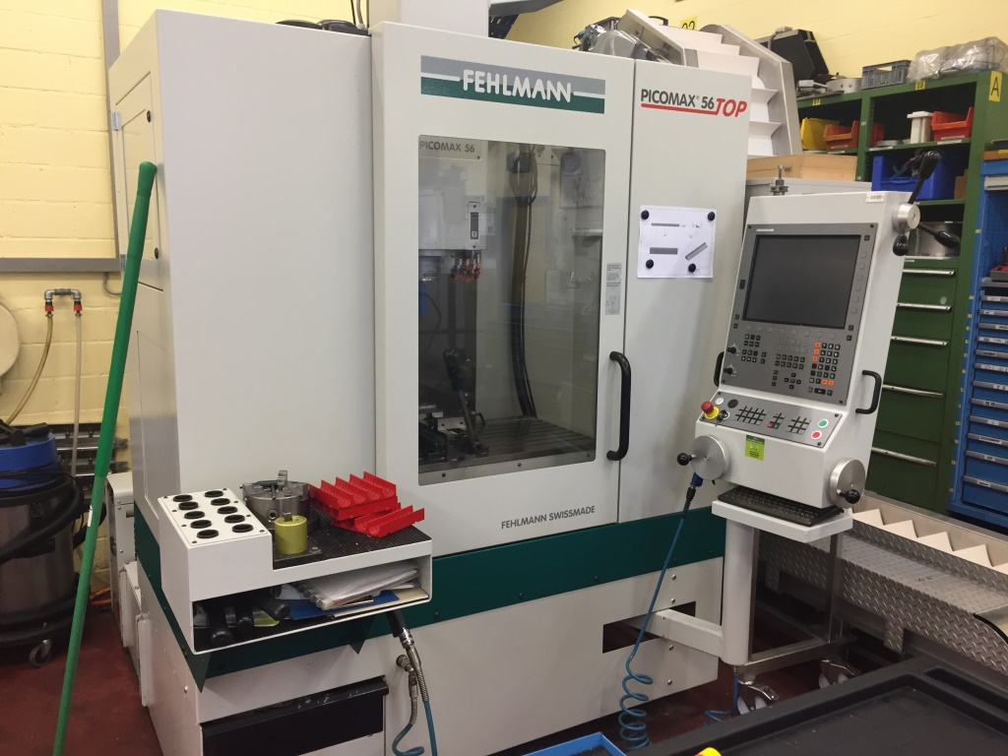

- Make : FEHLMANN SWISS
- Type : PICOMAX 56 TOP
- No :
- Age : 2014

- Capacity
- X travel : 500
- Y travel : 400
- Z travel : 400

- Table length : 908
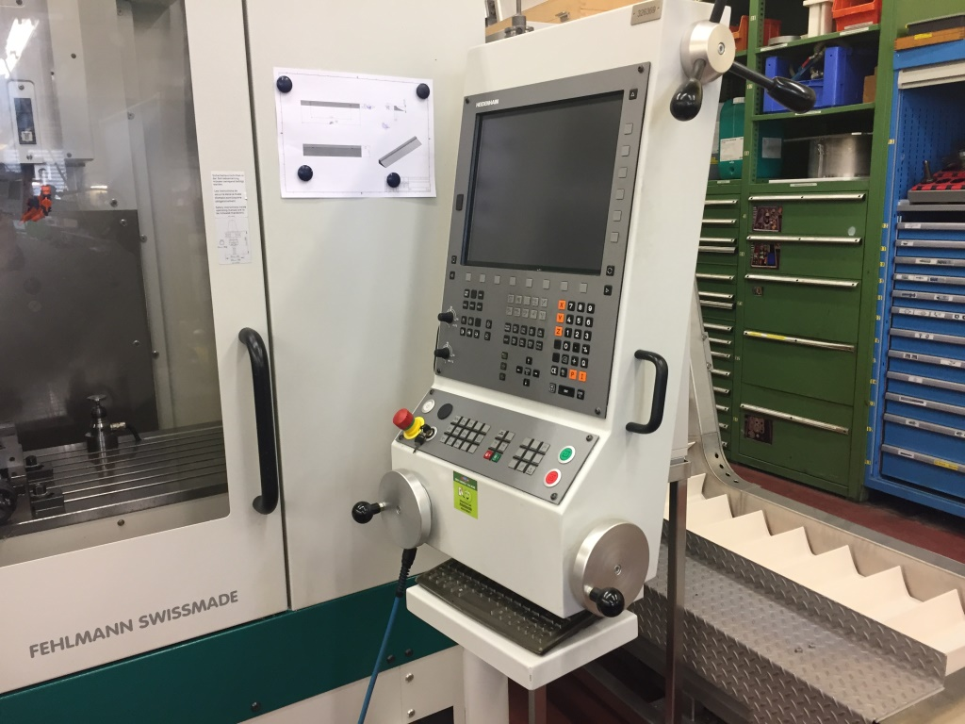
- Table width : 480
- Table load : 250

- Spindle speeds : 50 – 12.000
- Dis table – spindle : 120 - 520
- Power 40 % : 9.5 kW
- Spindle : ISO 30

- Feed rate X/Y/Z : 1 – 20.000 mm/M
- ATC 20 Positions
- Tool Ø 130 x 240 x 3 Kg
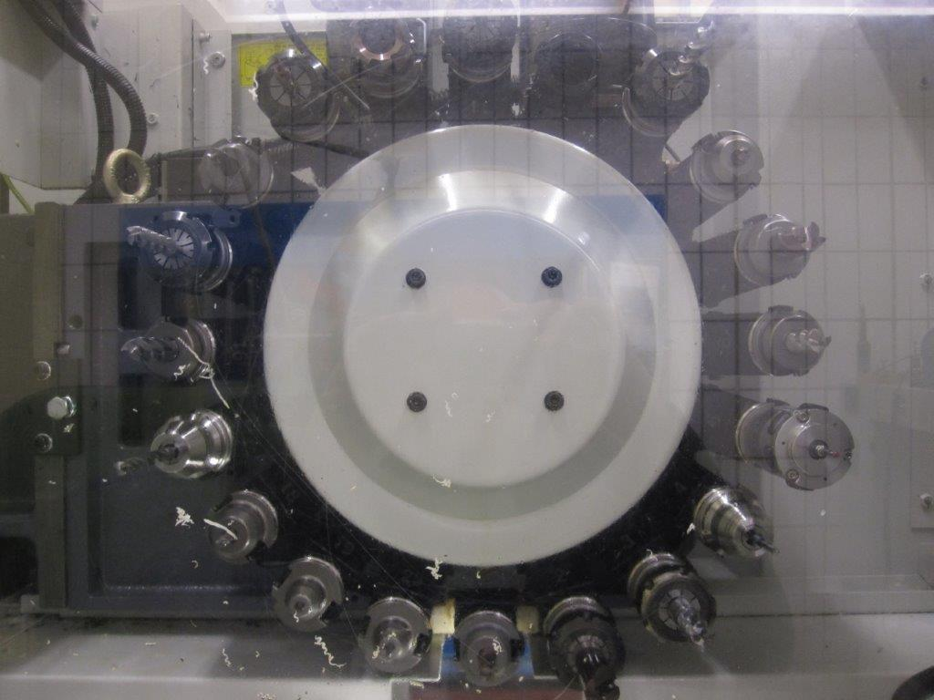
- HeidenHain TNC 530 in 3 axis

- Dimensions
- Length : 1882
- Width : 1700
- Height : 2536
- Weight : 3250

Please Note: The above information has been obtained to the best of our ability and belief from, and from the manufacturers where possible. It is given in good faith, but its accuracy can not be guaranteed. Accordingly, it will not form a representation or constitute contractual terms. We advise you to check any vital details!

